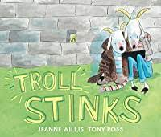
Before we read the text.

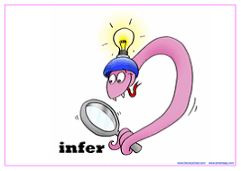
What can you see?
What do you think this story is going to be about? Explain why you think this.
Do you recognise any characters?
What does the front cover remind you of?

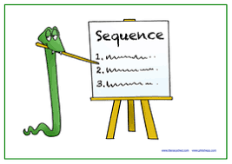
Whilst listening to the story, ‘The Three Billy Goats Gruff’, bullet point a sequence of main events.

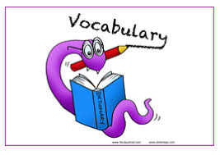Consider the character of the troll. What does the word mean?
Look up the various meanings in the Oxford English Dictionary: https://www.lexico.com/definition/troll

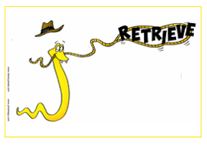
Write some words and phrases surrounding these illustrations.
Think about what the troll is doing as well as its appearance and features.
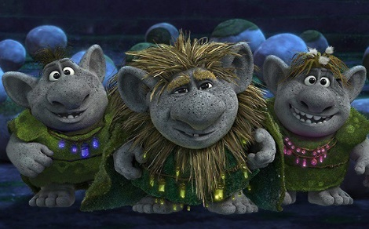
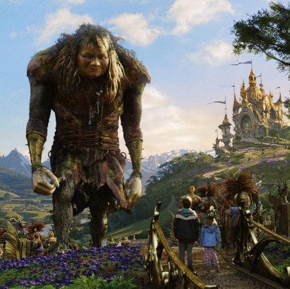
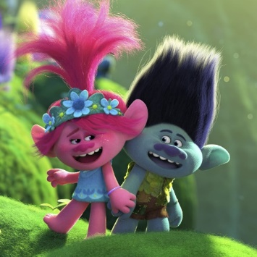
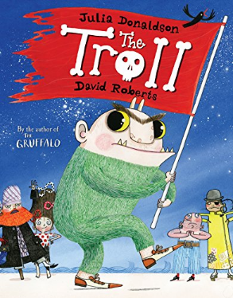

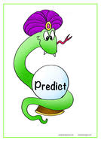
What predictions can you make about what might happen?

Think about: the definitions we read, your knowledge from the original story, your consideration of the character types and from front cover observations.

