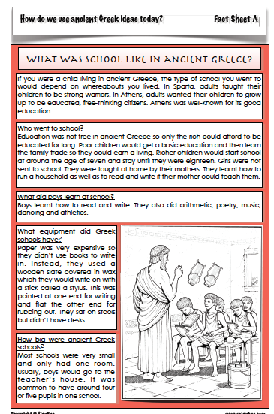

L.O: To understand what school was like in Ancient Greece

1. Which city state was well-known for its good education? _

2. Why did poor children only stay at school for a short time?

3. What did girls do instead of going to school?

4. When did rich boys start and finish school?

5. Which 5 subjects did children learn at school?

6. Why didn’t children use paper at school?

7. What is a stylus and what was it used for?

8. Whose house was the school usually held in?

9. Do you think you would have liked going to school in ancient
Greece? Why?

10. What do you think is the biggest difference between our schools
and schools in ancient Greece?

L.O; Comparing democracy

Read through the statements below and write or type them into the correct place in the table.

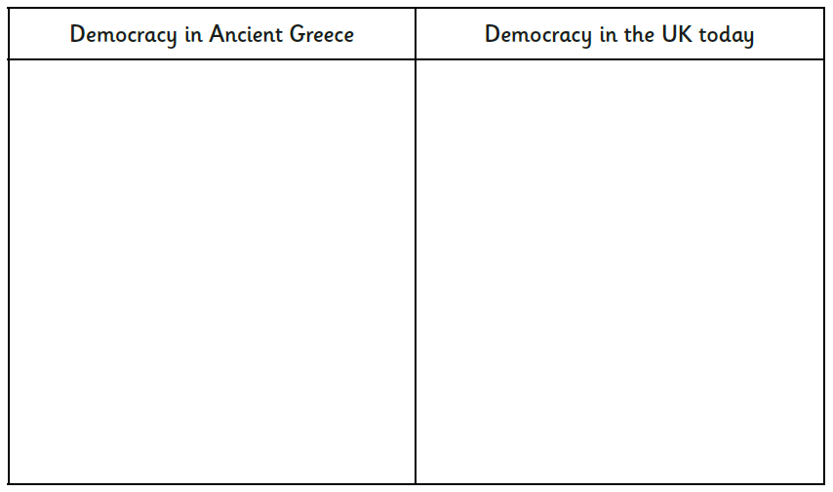

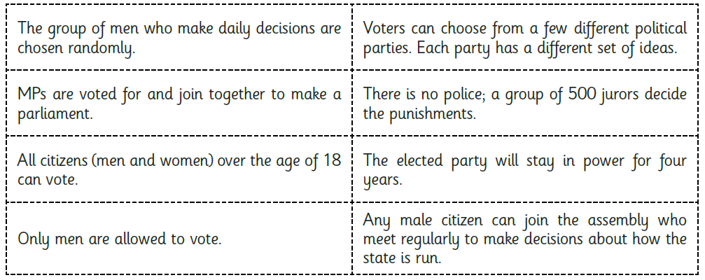

L.O: Exploring the Ancient Olympic Games
Watch the Horrible Histories video below to give you an idea of what the Ancient Olympics were like. Then, research the events below to see which events took place during the Ancient games, the modern games or appear in both.
Place the events into the Venn diagram below. You should be able to type straight into the diagram.

https://www.youtube.com/watch?v=z9lFwCDuj38



