Proposed Timetable for Chestnut class:.18.1.2021 18.1.21mpare de | Day 1 | Day 2 | Day 3 | Day 4 | Day 5
English:  Oak Academy  School Website  Purple Mash  www.spellzone.com | ENGLISH  To appreciate Greek Myths  https://www.bbc.co.uk/teach/school-radio/ks2-ancient-greece/zk73nrd  Have a listen to some of these myths. And make a list of the different Myths, the main character (hero), a quest, a challenge set by a god, a mythical beast. Use the sheet to help make your notes.  There are plenty of videos on line to see the Myths too. | ENGLISH  To find features of a Greek Myth  Read the myth and have a go at finding all the key features noted on the pink sheet. Mark on in a highlighter or make notes about the key features. | ENGLISH  To plan a greek Myth  Now time to think of your own Myth. Use the myth starter kit and pick out your different parts. The characters the powers and so on. Then start to plan with a spider diagram what might happen and how and where it could happen on a sheet of paper. | ENGLISH  To Plan a greek Myth  Now use your story board frame and the characters and parts from yesterday and put together a rough idea of how your story will flow.  Use the story board frame to map out your Myth you an always just type some notes up on a word document if that is easier. | ENGLISH  Spelling rule lesson  Soft G sounds  https://www.youtube.com/watch?v=c9c9osovrUU  Here is this weeks spellings please have a look at the clip to help you understand the rule. There is a worksheet to complete at the bottom of the page. You can print it or just do the answers on a sheet of paper.  I will do the test in the afternoon of the spellings in the 2.00pm session .
Maths:  BBC Bitesize White Rose  School Website work  Oak Academy  Purple Mash  Mathletics | MATHS  Adding and subtracting fractions with the same denominator  Using the worksheet in your work pack (Adding and subtracting fractions with the same denominator) find and colour the fractions to match the calculations. | MATHS  Adding fractions that are multiples of the same denominator.  https://www.youtube.com/watch?v=tDQipFjAoT8  Watch the clip on how to add fractions. Then have a go at the worksheet included underneath. | MATHS  Subtracting fractions that are multiples of the same denominator.  https://www.youtube.com/watch?v=c5dNa2TVHiQ  Watch the clip on how to subtract fractions. Then have a go at the worksheet included underneath. | MATHS  Adding and subtracting fractions with denominators that are multiples of the same number.  Using the Adding and Subtracting Fractions Sheet in your work pack, practise adding and subtracting fractions. Find two fractions with like denominators and add or subtract them showing your working out each time. | MATHS  Arithmetic skills  Practise and rehearse all four operations, fractions etc.  20 minute test and marking session.
Reading:  Books from home  Serial Mash | Cogheart reading session  2-2.30 live lesson  Read together and answer the guided reading questions.  Chapter 13-14  Vocab and inference | Cogheart reading session  2-2.30 live lesson  Read together and answer the guided reading questions.  Chapter 13-14  Prediction and explanation | Cogheart reading session  2-2.30 live lesson  Read together and answer the guided reading questions.  Chapter 13-14  Retrieve questions | Cogheart reading session  2-2.30 live lesson  .Read together and answer the guided reading questions.  Chapter 13-14  Summarise questions | Catch up  Next weeks’ time table certificates  Question time
Topic &  Other Activities  School Website Resources & Videos | In school PE session  Please try a Joe Wicks or one of the yoga sessions. | History and Geography  To understand what school was like in Ancient Greece  Read the fact file on what school life was like and answer the questions on the worksheet | In school PE session  Please try a Joe Wicks or one of the yoga sessions. | History and Geography  To compare democracy now and in Ancient Greece.  https://www.youtube.com/watch?v=52ncAgGnB5s  Watch the YouTube clip on decomacry in Ancient Greece.  Fill in the table comparing democracy now and democracy in Ancient Greece. | History and Geography  Exploring the Ancient Olympic Games.  https://www.youtube.com/watch?v=z9lFwCDuj38  Watch the Horrible Histories clip about the Ancient Games. then research different events from Ancient and Modern games
PE  Sport  Physical Exercise  ART | ART  Try making a Greek Mythical  Face mask.  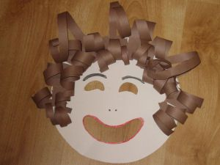  Use a paper plate or other materials and have a go at making a Medusa or a Hades or some of the other mythical creatures. | PE with Joe  Yay !!!  He is back on 3 times a week now because of lock down three see how fit you can get. Give it a go  Cosmic Kids Yoga  Lots of different yoga sessions linked to children’s stories  https://www.youtube.com/user/CosmicKidsYoga | ART  Try making a Greek Mythical  Face mask.  Use a paper plate or other materials and have a go at making a Medusa or a Hades or some of the other mythical creatures.  EMAIL PICTURES OF YOUR CREATIONS | PE with Joe  Yay !!!  He is back on 3 times a week now because of lock down three see how fit you can get. Give it a go  Go Noodle  Active videos to chart songs – take your pick and have a go at a few different videos.  https://www.gonoodle.com  or  https://www.youtube.com/user/GoNoodleGame | PE with Joe  Yay !!!  He is back on 3 times a week now because of lock down three see how fit you can get. Give it a go

Hello Chestnut Class!
Here we are week three; it seems as if we have all settled into a nice routine with the online lessons. It is great to see all the work you are doing and anything you have sent we have printed off ready for you to stick in your books when we are back. Again below there are some of the work sheets to help with the work please scroll to the end to find them.
Have a great week and stay safe!
Mrs Bick , Mrs Davies & Mrs Beasley.

Maths lesson 2

Name of Myth | Names of Characters | The Quest or problem | Mythical Beast monster | Resolution

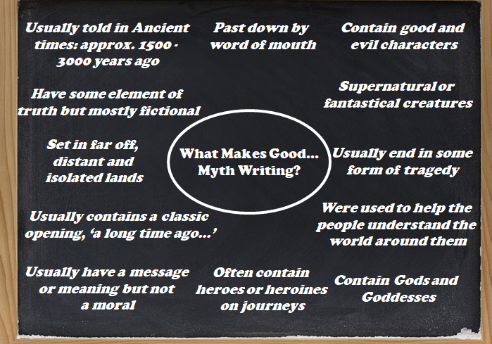

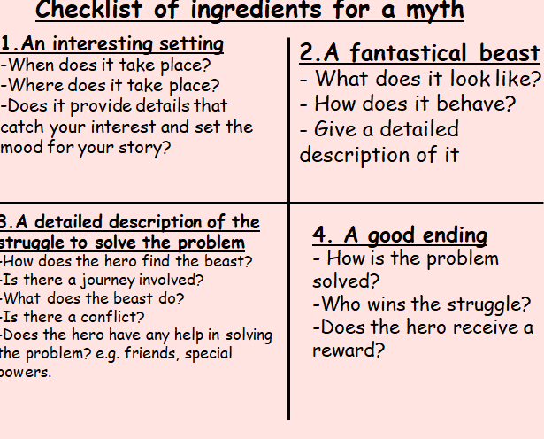

Theseus and the Minotaur – children’s version.
Once upon a time, a long time ago, there lived a king named Minos. King Minos lived on a lovely island called Crete. King Minos had a powerful navy, a beautiful daughter, and a really big palace. Still, now and then, King Minos grew bored. Whenever King Minos was bored, he took his navy and attacked Athens, a town on the other side of the sea.
The people of Athens soon grew tired of the bully, King Minos. All the people of Athens agreed that something had to be done. Athens tried to make friends with King Minos, but nothing seemed to work. In desperation, the king of Athens offered King Minos a deal. If Minos would leave Athens alone, Athens would send seven Athenian boys and seven Athenian girls to Crete every nine years to be eaten by the Minotaur.
The Minotaur was a horrible monster that lived in the center of a huge maze on the island of Crete. King Minos loved that old monster. He did like to give his monster a treat to eat now and then. King Minos knew his people would prefer he fed his monster Athenian children as a treat rather than the children of Crete. King Minos took the deal.
Nine years passed swiftly. It was just about time for Athens to send seven boys and seven girls to Crete to be eaten by the Minotaur. Everyone in Athens was crying. Prince Theseus of Athens was very young. He knew that a deal was a deal. Still, he was sure it was wrong to send small children to be eaten by a monster just to avoid a battle with King Minos. Prince Theseus told his father (the king) that he was going to Crete as the seventh son of Athens. He was going to kill the Minotaur and end this terror.
"The Minotaur is a terrible monster! What makes you think you can kill it?" cried his father.
"I'll find a way," Theseus replied gently. "The gods will help me."
His father begged him not to go. He was afraid his son would be eaten. But the prince was determined. Theseus took his place as the seventh Athenian boy. Along with six other Athenian boys and seven Athenian girls, Prince Theseus sailed towards Crete.
When the prince and the children arrived, King Minos and his daughter, the Princess Ariadne, came out to greet them. The king told them that they would not be eaten until the next day and to feel free to enjoy themselves in the palace in the meantime. The Princess Ariadne did not say anything. Her eyes narrowed thoughtfully. Late that night, she wrote Prince Theseus a note and slipped it under his bedroom door.
Dear Theseus (Ariadne wrote)
I am a beautiful princess as you probably noticed the minute you saw me. I am also a very bored princess. Without my help, the Minotaur will surely gobble you up. I know a trick or two that will save your life. If I help you kill the monster, you must promise to take me away from this tiny island so that others can admire my beauty. If interested in this deal, meet me by the gate to the Labyrinth in one hour.
Yours very truly,
Princess Ariadne
Prince Theseus slipped out of the palace and waited patiently by the gate. Princess Ariadne finally showed up. In her hands, she carried a sword and a ball of string.
Ariadne gave the sword and the ball of string to Prince Theseus. "Hide these inside the entrance to the maze. Tomorrow, when you and children from Athens enter the Labyrinth, wait until the gate is closed, then tie the string to the door. Unroll it as you move through the maze. That way, you can find your way back again. The sword, well, you know what to do with the sword," she laughed.
Theseus thanked the princess for her kindness.
"Don't forget, now," she cautioned Theseus. "You must take me with you so that all the people can marvel at my beauty. A deal is a deal."
The next morning, all the Athenian children, including Prince Theseus, were shoved into the maze. The door was locked firmly behind them. Following Ariadne's directions, Theseus tied one end of the string to the door. He told the children to stay by the door. Their job was to make sure the string stayed tied so that Theseus could find his way back to save them. Theseus entered the maze alone.
It took him a while, but he finally found his way to the center. Using the sword Ariadne had given him, Theseus killed the monstrous beast. He followed the string back and knocked on the door.
Princess Ariadne was waiting. She opened the door. Without anyone noticing, Prince Theseus and the children of Athens ran to their ship and sailed quietly away. Princess Ariadne sailed away with them.
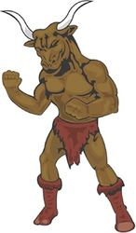
On the way home, they stopped for supplies on the tiny island of Naxos. Princess Ariadne insisted on coming ashore. There was nothing much to do on the island, and soon, she fell asleep. Many people gathered to watch the sleeping princess. She was a lovely sight indeed. All the people agreed. Theseus sailed away with the children of Athens and left her there, sleeping.
After all, a deal is a deal.

Make Your Own Greek Myth

Instructions

- Each set of cards relates to a different aspect of a Greek Myth;
      - The ‘make up’ of the beast which the hero fights.
      - Hero’s special power
      - Who helps the hero.
      - The challenge the hero is set
      - The special weapon the hero has
      - Who tries to defeat/kill the hero.

- Cut up the cards but keep each set separate (I keep then in little envelopes)

- Get the students to take one set at a time, lay them face down and mix them up.

- Students then choose one card and that becomes one aspect they must include in their Greek Myth. *N.B. With set 1 (the ‘make up’ of the beast) you could get the students to choose more than one card to make their beats more interesting!*

I find that this way makes the students stories more interesting and less clichéd. They really have to think hard about how they are going to get all the aspects into their myth.

1 | Snake | Lion
1 | Horse | Eagle
1 | Bull | Goat
1 | Lizard | Crocodile

2 | Strength | Speed
2 | Flight | Intelligence
2 | Bravery | Musical

3 | God | Goddess
3 | Wise man | King

4 | Complete a challenge | Slay a beast
4 | Get a prize | Win a woman’s heart

5 | Sword | Shield
5 | Bow | Arrows
5 | Dagger | Spear

6 | Wicked father | Prisoner of beast
6 | Orphaned | Lost
6 | Sorceress | Princess

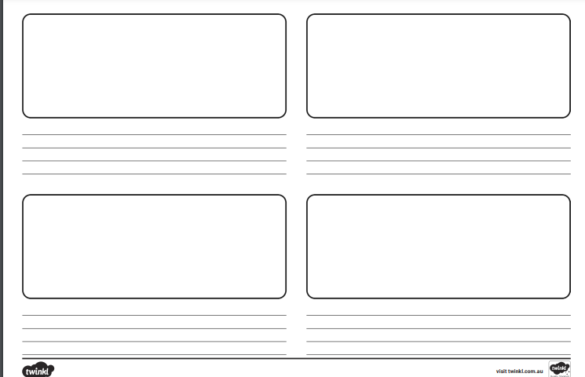

Genuine
Generous
Emergency
Apology
Legend
Judgement
Suggestion
Gorgeous
Exaggerate
Tragic
Gigantic
Gymnast
Origin
Privilege
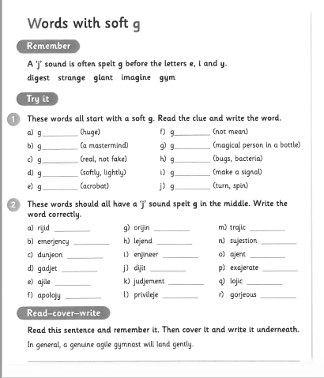

L.O: Adding fractions with denominators that are 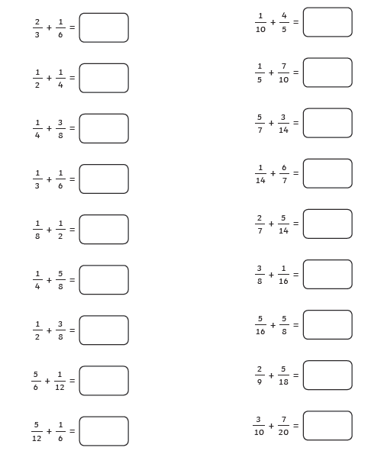multiples of the same number

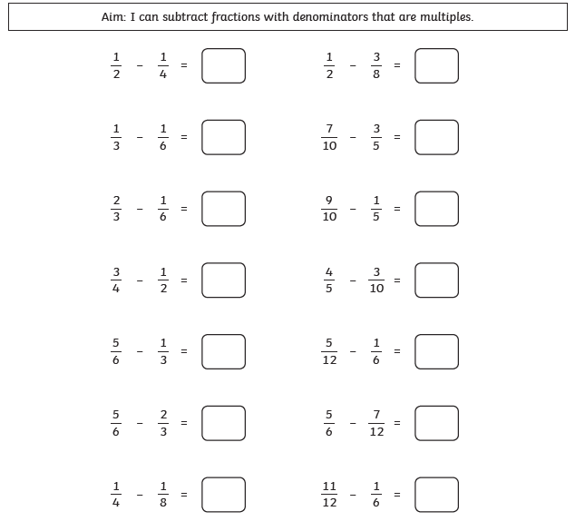
Maths lesson 3.

