Reception Learning timetable - Week 6
Chinese New Year – information and clips can be found at https://www.topmarks.co.uk/chinesenewyear/chinesenewyear.aspx
 | Monday | Tuesday | Wednesday | Thursday | Friday
Phonics and Literacy | Phonics  Teacher led activity on Teams. Today’s Grapheme: TBC  Time and date: 9:30 am daily Mon – Fri. Invitations are sent through each child’s welearn account. Reading opportunities – attempt to read the nonsense words in your pack.  Literacy  Explain to the children that it is a very special celebration for people all over the world. Watch the CBeebies clip of a family preparing for Chinese New Year https://www.youtube.com/watch?v=c8ssHXZ9_qU | Phonics  Teacher led activity on Teams.  Today’s Grapheme: TBC  Time and date: 9:30 am daily Mon – Fri. Invitations are sent through each child’s welearn account. Reading opportunities – attempt to read the nonsense words in your pack.  Literacy  Watch the CBeebies clip about a family celebrating Chinese New Year https://www.youtube.com/watch?v=1cRMRp9-Z08 | Phonics  Teacher led activity on Teams.  Today’s Grapheme: TBC  Time and date: 9:30 am daily Mon – Fri. Invitations are sent through each child’s welearn account. Reading opportunities – attempt to read the nonsense words in your pack.  Literacy Live lesson 11am  Look at information about China including The Great Wall of China  Write a sentence about China. | Phonics  Teacher led activity on Teams.  Today’s Grapheme: TBC  Time and date: 9:30am daily Mon – Fri. Invitations are sent through each child’s welearn account. Reading opportunities – attempt to read the nonsense words in your pack.  Literacy | Phonics  Teacher led activity on Teams.  Today’s Grapheme: TBC  Time and date: 9:30am daily Mon – Fri. Invitations are sent through each child’s welearn account. Reading opportunities – attempt to read the nonsense words in your pack.  Literacy
Numeracy lessons | Live lesson at 11.00am Ordinal numbers In preparation for the lesson watch the story of Chinese New Year on Topmarks https://www.topmarks.co.uk/chinesenewyear/chinesenewyear.aspx or CBeebies https://www.youtube.com/watch?v=eVClAj8q_lY  The new year will be the Year of the Ox.  Can you use the Animals and Years Poster to work out which year you were born? | Live lesson at 11.00am  Please have the cards with the animals on cut up and ready for today’s lesson.  Today we will be learning Ordinal numbers – 1st, 2nd, 3rd etc.  Put the cards in order. Discuss positions.  Mix up cards, can your child order the cards on their own? | Parent led Lesson  Look at the Twinkl PowerPoint (Teams File) to see the order of the animals. Use your pictures of the animals and a long strip of paper to stick down the animals the correct order.  Make a list of the animals on a separate piece of paper. Ask your child to write 1st, 2nd, 3rd, etc next to each one. | Live lesson at 11.00am  Using the animal cards from yesterday’s lesson ask questions using positional language such as “Which animal was in front of the dog?” “Who was behind/ in between the tiger?” etc. | Live lesson at 11.00am  Discuss the order of the days of the week. ‘Monday is the first day of the week.’ Use a chart from the internet to challenge your child to say which day is the second etc. Ask your child to tell you about months of the year: January is the first month etc. Ask if they know the date of their birthday? Ask them to work out which ordinal month their birthday is in. Link with quick date.
Reading | Oxford owl – using your child’s login (front page of their reading dairy), pick a book to read and complete the play activities. Revisit the story if you feel it is necessary. | Oxford owl – using your child’s login (front page of their reading dairy), pick a book to read and complete the play activities. Revisit the story if you feel it is necessary. | Oxford owl – using your child’s login (front page of their reading dairy), pick a book to read and complete the play activities. Revisit the story if you feel it is necessary. | Oxford owl – using your child’s login (front page of their reading dairy), pick a book to read and complete the play activities. Revisit the story if you feel it is necessary. | Oxford owl – using your child’s login (front page of their reading dairy), pick a book to read and complete the play activities. Revisit the story if you feel it is necessary.
Topic | 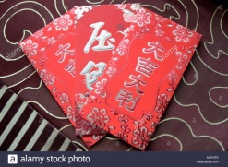  Make a Chinese Good Luck purse using the red paper in your pack. Decorate your purse with some Chinese writing. Put the chocolate coin in your purse. | Make a Chinese lantern using the black paper. Cut slits into the paper. Decorate the paper on one side. Join the two edges together to make the lantern.  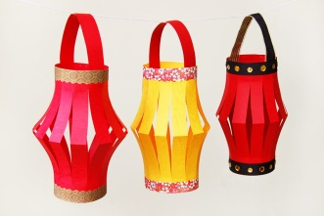 | Chinese food tasting  Get some raw noodles (super noodles are great for this activity). Discuss what they look / feel like. Demonstrate how to cook the noodles. Talk about the changes you see. Taste the noodles, describe how they taste. Do you like the taste? | Origami  Look at examples of the ancient art of origami online. Watch the clip to show you how to make an origami ox https://www.youtube.com/watch?v=8pKz3mY78V8  Use the coloured paper in your pack to make an origami ox.  Can you make any other origami animals? | PE – Dragon Dancing  Watch the dragon dancing clip https://www.youtube.com/watch?v=3tqgPo5HVts . Join in with the actions. Can you sue objects in your home to make some music to dance along to?
PE | Here are some YouTube links of different workout videos you may like to take part in. If you do not want to take part in these workout videos, maybe go for a walk around the Village. You may want to do some gymnastics or throwing and catching. We cannot wait to see what you get up to this week.  The Body Coach TV - YouTube  Physical Education KS1 / KS2: Let's Get Active - BBC Teach  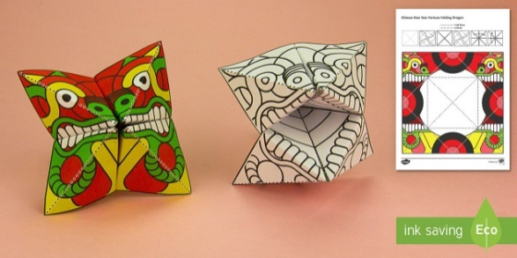  Cosmic Kids Yoga - YouTube
Story time | Pick a story to have read to by a member of your family. This could be at any time of the day. You can find most  books on YouTube, however here are some useful links for websites with free access to books.  https://magicblox.com/  https://www.bookbotkids.com/free-books-for-kids  https://www.booktrust.org.uk/books-and-reading/have-some-fun/storybooks-and-games/
Finger gym | Make a dragon chatter box (sheet in your pack)  Can you use your forefingers and thumb to make it work? Can you move its mouth as you talk?
Hello Reception,
Here are your weekly suggestions for Phonics and Literacy, Numeracy, Reading, Topic, PE and a story at the end of the day. You can do them in which ever order you like. We do not expect you to be doing it all. So you can dip in and out, pick other activities or use your own resources if you prefer. Please feel free to contact us via email.
Have a great week and stay safe!
The Reception Team. whitmore.h@welearn365.com houghton.s@welearn365.com perks.m@welearn365.com

