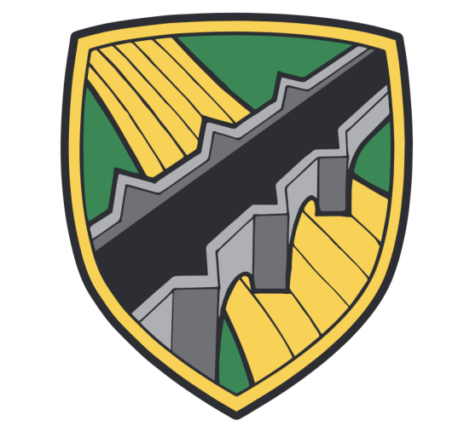
WATER ORTON PRIMARY SCHOOL
Plank Lane, Water Orton, Birmingham. B46 1SG
Tel: 0121 747 2851 Website: www.waterortonprimary.co.uk
Email: admin2618@welearn365.com Follow us on Twitter @WOPrimary



Dear Parents/Careers,
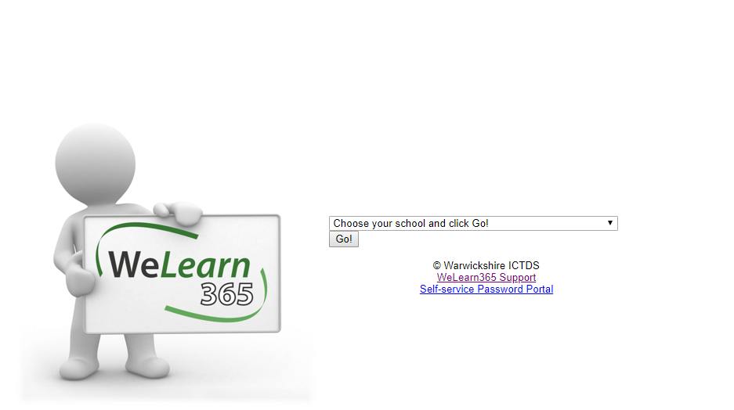
As you know our online learning provision is a combination of live lessons which take place on Microsoft Teams and work which has been published on the website. There is lots of information on the school website about how to access WeLearn and Teams but we have put together this guidance should you need further assistance.

Accessing WeLearn
- Open the browser (Safari, Google Chrome, Internet Explorer etc.)
- Search ‘WeLearn365’, click on the ‘WeLearn365 Homepage’ option.
- Select Water Orton Primary from the drop down menu.
- Type in your child’s username and password (found in their diary).
- Once you are in to WeLearn follow the instructions below for the service you want to access.
Accessing Purple Mash
- Open the WeLearn platform (see instructions above)
- Select the Purple Mash icon.
Accessing Teams
- Open the WeLearn platform (see instructions above)
- Navigate to the nine dots, top left hand side of the page.
- Select ‘Teams’ from the menu which appears on the left.
- Teams will open, find the calendar tab on the left hand side and join the meeting set by the teacher.
Accessing your child’s emails
- Open the WeLearn Platform (see instructions above)
- Click on the my mail tab (next to Purple Mash)
Frequently Asked Questions
- My Child’s log in will not work, who should I contact? Please double check the steps above and that you are accessing the services needed through WeLearn. If you are still having trouble email Miss Ward ward.j2@welearn365.com
- My child has left their dairy at school and their class has been asked to isolate, who should I contact? Due to GDPR we are not allowed to provide teachers with their own list of passwords. You will need to email Miss Ward ward.j2@welearn365.com
- I have more than one child at Water Orton and it keeps logging me in as one child even though I have logged in as my other child, what do I do? This is quite a common error, if you have privacy/incognito mode on your device we recommend you use it. If however you do not you will need to sign out of your child’s account before logging in on the other child’s account. There are some steps below to help with this.
Logging out of my child’s WeLearn Account
- Open the WeLearn platform (see instructions above)
- Navigate to the coloured circle on the top right hand side of the screen which should have the initial of your child’s first name and a W for Water Orton.
- Select the circle and press sign out.
- This should then mean you are able to log in on your other child’s account.
If you are still unable to access the service, please do contact us so that we can support you and your child.

Miss Ward
Computing and Online Safety Lead

