
WATER ORTON PRIMARY SCHOOL
Plank Lane, Water Orton, Birmingham. B46 1SG
Tel: 0121 747 2851 Website: www.waterortonprimary.co.uk
Email: admin2618@welearn365.com Follow us on Twitter @WOPrimary



Dear Parents/Careers,
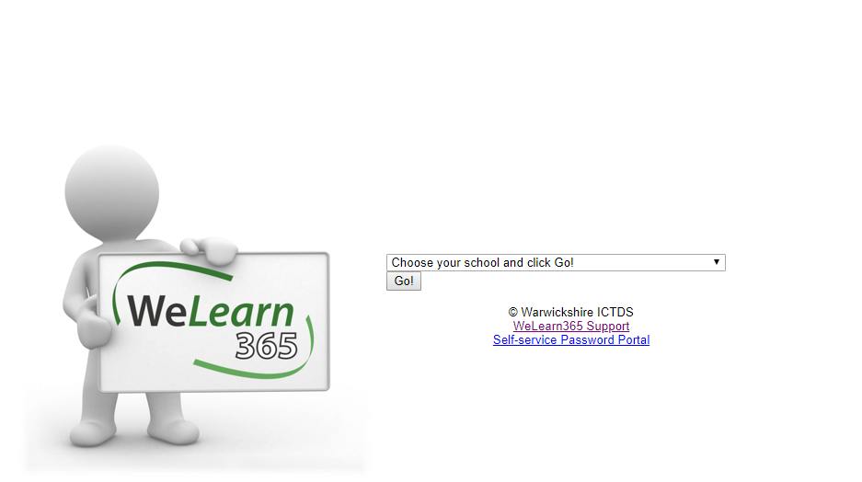
As you know our online learning provision is a combination of live lessons which take place on Microsoft Teams and work which has been published on the website. There is lots of information on the school website about how to access WeLearn and Teams but we have put together this guidance should you need further assistance.

Accessing WeLearn
- Open the browser (Safari, Google Chrome, Internet Explorer etc.)
- Search ‘WeLearn365’, click on the ‘WeLearn365 Homepage’ option.
- Select Water Orton Primary from the drop down menu.
- Type in your child’s username and password (found in their diary).
- Once you are in to WeLearn follow the instructions below for the service you want to access.
Accessing Purple Mash
- Open the WeLearn platform (see instructions above)
- Select the Purple Mash icon.
Accessing Teams
- Open the WeLearn platform (see instructions above)
- Navigate to the nine dots, top left hand side of the page.
- Select ‘Teams’ from the menu which appears on the left.
- Teams will open, find the calendar tab on the left hand side and join the meeting set by the teacher.
- Alternatively, you can access teams by downloading the app and log in with your child’s email and password (see logging into my child’s Teams account below). Then Teams will open, find the calendar tab on the left hand side and join the meeting set by the teacher.
Accessing your child’s emails
- Open the WeLearn Platform (see instructions above)
- Click on the my mail tab (next to Purple Mash)
Logging out of my child’s WeLearn Account
- Open the WeLearn platform (see instructions above)
- Navigate to the coloured circle on the top right hand side of the screen which should have the initial of your child’s first name and a W for Water Orton.
- Select the circle and press sign out.
- This should then mean you are able to log in on your other child’s account.

Logging out of my Teams account and into my child’s Team account
- Open the Teams App
- Navigate to the coloured circle on the top right-hand side of the screen which should have the initials of the account you are currently logged in to.
- Click on the circle and when the drop down appears select sign out.
- Then re-open the Teams app and when prompted enter your child’s email. Their email is their usual WeLearn/Purple Mash username followed by ‘@welearn365.com’ so for example. A.example7 may be your child’s WeLearn username by their email is a.example7@welearn365.com
- Once you have put in their email address you will be taken to the organisations sign in page (blue and white) When you have reached this page you will need to enter your child’s username and password.
- This should then log you in to your child’s account. You will find you have many more functions.
Pinning someone to the screen in Teams

- When you are already in a meeting, head to the people icon which tells you who is in the meeting (see picture below)

- Then find the person who you want to be able to see
- Hover over their name until three dots appear
- Click the three dots next to the person's name and press pin (see picture below) this will ensure that this person stays on the screen.
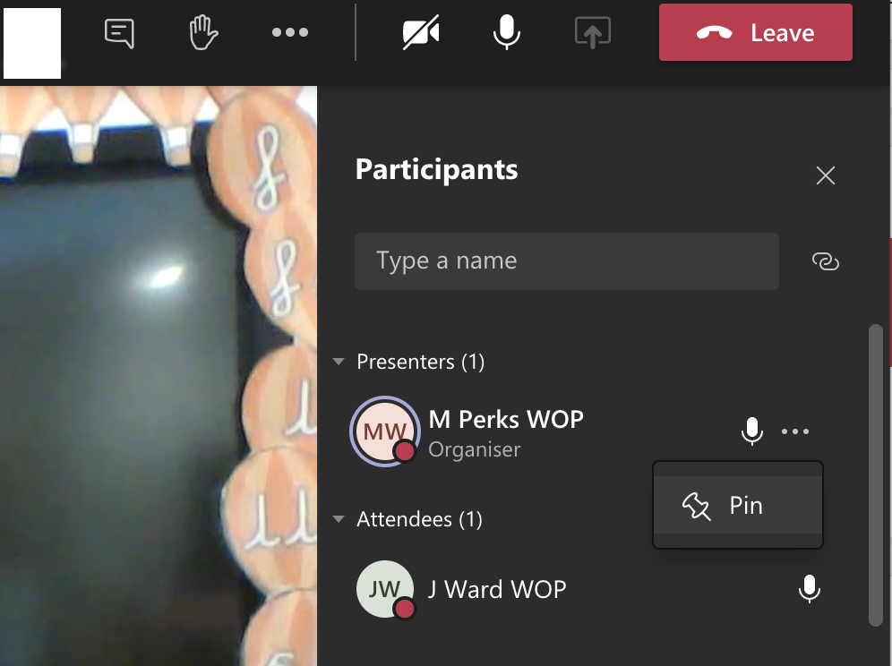

Finding recorded lessons
- Navigate to the Teams icon on the left-hand side of the platform. Select the team that the meeting was held with.
- Find the session you wish to watch and then select ‘replies’ tab underneath the meeting time and date (see image below)
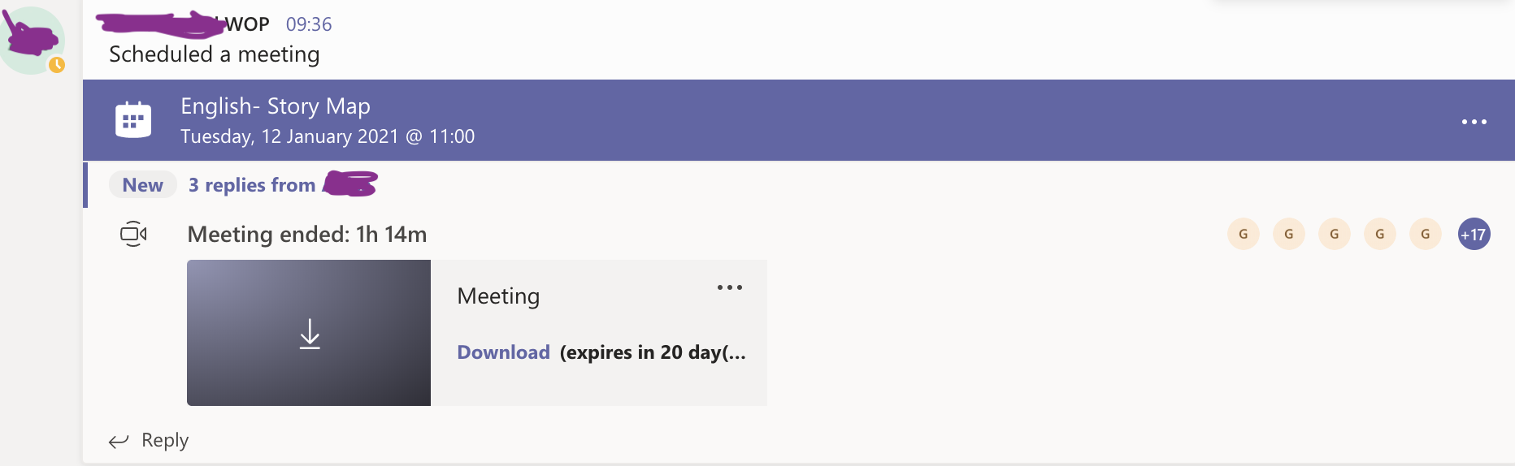
- You should then see the recording of the session by clicking on this you are able to watch back the session at a later date.

Frequently Asked Questions
- My Child’s log in will not work, who should I contact? Please double check the steps above and that you are accessing the services needed through WeLearn. If you are still having trouble email Miss Ward ward.j2@welearn365.com
- My child has left their dairy at school and their class has been asked to isolate, who should I contact? Due to GDPR we are not allowed to provide teachers with their own list of passwords. You will need to email Miss Ward ward.j2@welearn365.com
- I have more than one child at Water Orton and it keeps logging me in as one child even though I have logged in as my other child, what do I do? This is quite a common error, if you have privacy/incognito mode on your device we recommend you use it. If however you do not you will need to sign out of your child’s account before logging in on the other child’s account. There are some steps above to help with this.
- I can’t see the screen share in Teams and the chat function is not available, why is this? This is likely to be down to how the device you are using is signed in to Teams. Please log out and re-enter your child’s log in information (see instructions above)
- The staff in school are telling me I cannot access the meetings on Teams because I am logged in on my account. I don’t understand why this is because I am going through the WeLearn log in for my child. This happens because the Teams app has been logged in on another account, you will need to log the Teams app out of the app it is currently logged in as and log in as your child (using the instructions above)
- Sometimes when in a Teams meeting, I am not able to see the Teacher leading the session. Is there something I can change in the settings? A few people have mentioned this depending on which device they are using, try following the instructions for pinning someone (see above)
- I had another meeting and couldn’t log on for the live lesson today, how can we watch the recording? Please see the instructions above with how to access the recordings for the missed live lessons.

If you are still unable to access the service, please do contact us so that we can support you and your child.

Miss Ward

Computing and Online Safety Lead
Ward.j2@welearn365.com

