Year 3 & 4 Spring Homework
Vikings

Research Skills  Create a fact file on your favourite Viking God.  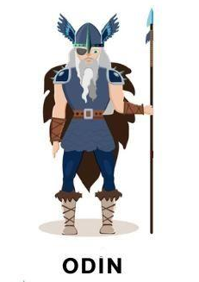 | English Skills  Write a message in Viking runes.  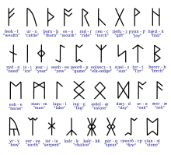 | Creative Skills  Design and make a Viking shield or helmet.  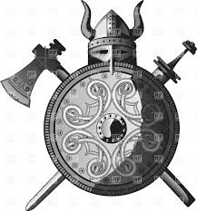 | Mathematical Skills  Draw a picture of a symmetrical longboat or longhouse. Give measurements and use tracing paper to show lines of symmetry
Creative Skills  Design a poster for a new Viking god-based film.   | PE Skills  Vikings had to be fit and strong. Create a Viking exercise regime – think about repetitions, timings and exercises to build muscles.  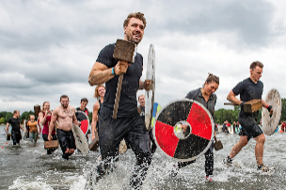 | Research  Research Sutton Hoo. Find out about the Anglo-Saxon burial ground and the treasures that lie there.  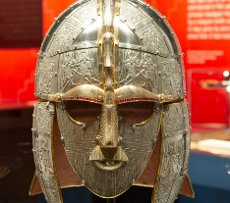 | Design Skills  Design a Viking board game and write detailed instructions of how to play it.  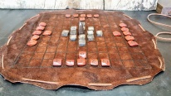
Mathematical Skills  Design a Viking shield – use symmetrical patterns and bold colours to frighten your enemies!  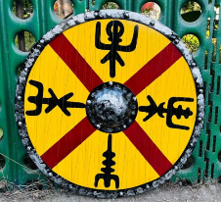 | Research  York was a famous Viking settlement known as Jorvik. Find out about landmarks in York and how the Vikings lived.  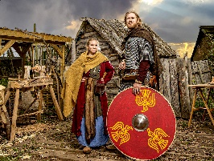 | English Skills  Find out about Alfred the Great. Explain what he did and why he is so significant in Anglo Saxon history.  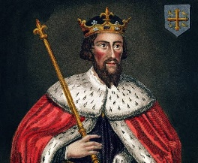 | Geography Skills  Use Google maps to find out about one of the countries that Vikings originated from.  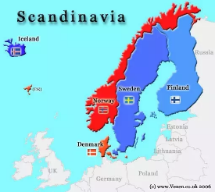
English Skills  Design a piece of Viking jewellery and write an advert to encourage people to buy it.  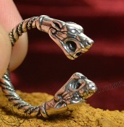 | Creative Skills  Create your own Viking Longship out of materials you can find at home.  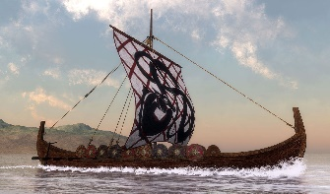 | Geography Skills  Find out about the phenomena of the Northern Lights. Where do they happen and what causes them?   | Visit  Visit the Staffordshire Hoard. Find out what it is and how it was discovered.  

